ARCHITECT REVIEW
SALDEV-1473 | Multiple Ship-to Account Header Fix
FlywirePartial | Deployed Flow correction and functional validation
Source | FlywirePartial | Enterprise sandbox 00DhG0000000jOXUAY | USA1148S
Test record | Q-37873 | Draft | 44 lines | 32 ramped | 2 ship-to accounts
Review date | 1 September 2026
Validation mode | Live metadata read-back | check-only | deployment | QLE Quick Save | SOQL read-back
Decision | APPROVE / PASS - Primary acceptance criterion verified in FlywirePartial
Boundary | Version 8 active; no Production change and no bulk record backfill

ARCHITECT DECISION
Approve SALDEV-1473 in FlywirePartial for the primary acceptance criterion. Flow version 8 is active, both validations succeeded, and Q-37873 changed from No to Yes on Quick Save with independent SOQL read-back. Complete the listed regression cases before promotion beyond the sandbox.

Acceptance outcome
# | Scope | Result | Evidence
1 | Story acceptance | PASS | Q-37873 changed Multiple Ship to Accounts from No to Yes after Quick Save.
2 | Quote-wide calculation | PASS | 44 lines included two ship-to accounts; six lines used the alternate account.
3 | Stepped / mixed groups | PASS | The quote had five groups, 32 ramped lines, and 12 non-ramped lines.
4 | Create and update path | IMPLEMENTED | Active version 8 uses CreateAndUpdate with RecordAfterSave.
5 | Deployment integrity | PASS | Check-only and deployment each validated one Flow with zero component errors.
6 | Regression breadth | FOLLOW-UP | Pure non-stepped, alternate ramped-line, Yes-to-No, and delete-only cases remain.

Root cause and correction path
The defect was a record-by-record last-writer race. Flow version 8 now evaluates all quote lines after create or update and derives one deterministic header value from direct or inherited ship-to accounts.
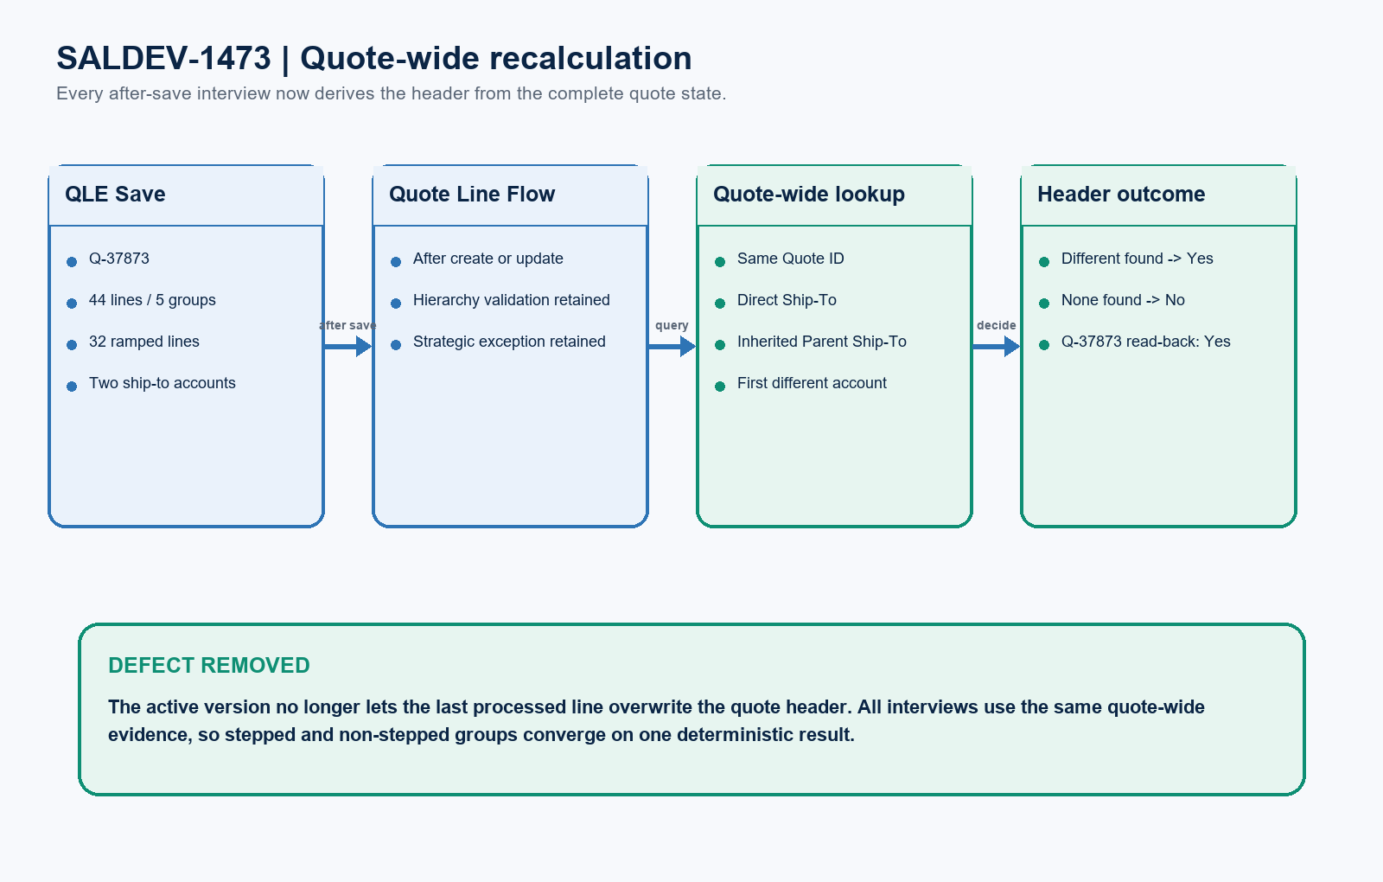
Figure 1. SALDEV-1473 quote-wide recalculation in FlywirePartial
DESIGN READING
Blue is preserved control logic. Green is the quote-wide correction and verified live evidence. Amber is recommended regression coverage before promotion beyond Partial.

Detailed implementation and validation

1. Live org and version evidence
Evidence area | Observed result | Evidence
Target org | FlywirePartial | Flywire Enterprise sandbox 00DhG0000000jOXUAY; instance USA1148S.
Prior active Flow | Version 6 | Update-only and line-by-line; became obsolete after version 8 activation.
Prior attempted Flow | Version 7 | Obsolete; changed only the trigger to CreateAndUpdate.
Current Flow | Version 8 Active | 301hG00000BfrsBQAR is both ActiveVersionId and LatestVersionId.
Mismatch sample | 24 of 155 quotes | 2,000 recent lines showed 24 incorrect No headers; 15 included ramped lines.

2. Deployment and metadata outcome
Deployment gate | Result | Evidence
Check-only | PASS | 0AfhG000001bMygSAE | 1 Flow | 0 component errors | CheckOnly=true.
Deployment | PASS | 0AfhG000001bPN5SAM | 1 Flow | 0 component errors | CheckOnly=false.
Metadata read-back | PASS | CreateAndUpdate, RecordAfterSave, six lookup filters, expected Yes/No routing.

3. Functional result and coverage boundary
Test / boundary | Status | Evidence
Primary QLE test | PASS | Q-37873 Quick Save updated the header to Yes; independent SOQL confirmed Yes.
Record remained safe | PASS | Quote remained Draft and non-ordered; no line values were intentionally edited.
Mixed-group detection | PASS | Ramped and non-ramped groups coexisted; alternate ship-to lines were detected.
Yes-to-No reset | PENDING | Use a separate clone and return the final alternate ship-to line to the quote account.
Delete-only reset | SEPARATE SCOPE | The active Flow handles create/update; delete-only recalculation needs a decision.

Quote-wide Flow architecture
The correction adds one focused Get Records element and changes decision routing while preserving hierarchy validation, the Strategic Partner exception, and Renewal plus Upsell behavior.
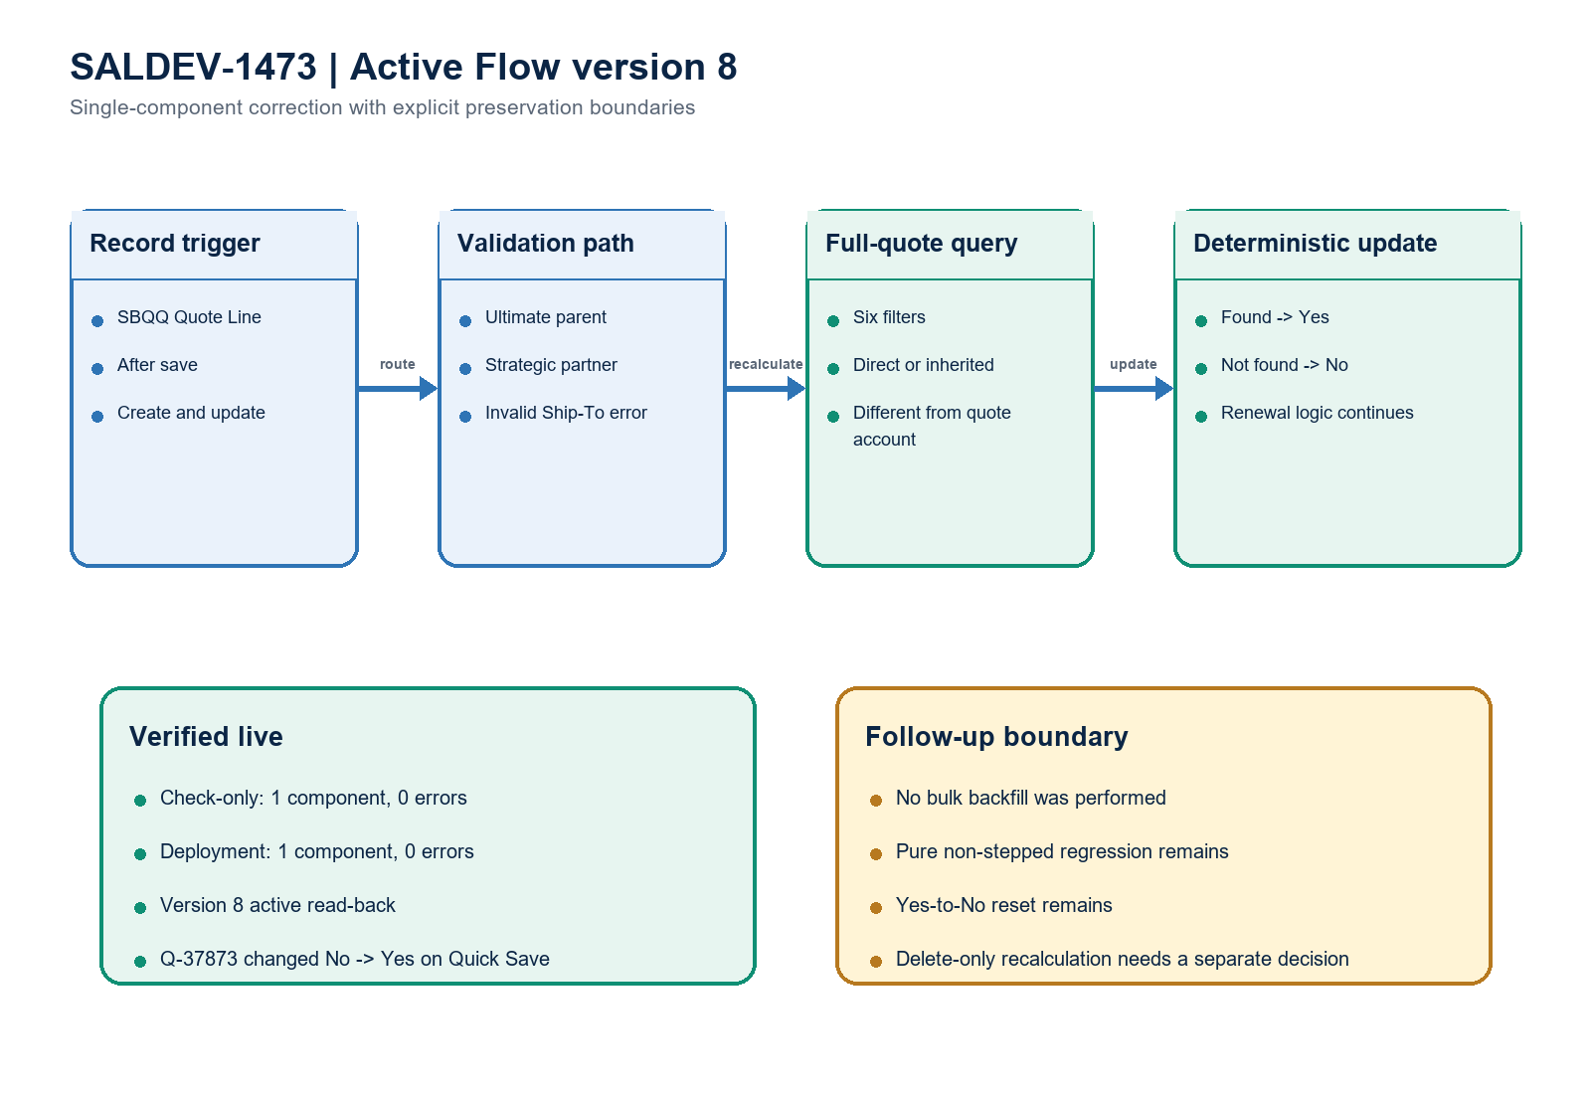
Figure 2. SALDEV-1473 active Flow version 8 and validation boundary
Architect interpretation: the single-line calculation was the failure mode. The new full-quote query removes processing-order dependence and passed the named stepped/mixed QLE acceptance test.

Recommended completion gates
Gate | Recommended action | Owner | Evidence needed
1 | Run pure non-stepped regression | CPQ QA | Quote without ramped groups; verify No -> Yes and stable Quick Save.
2 | Use alternate account on ramped line | CPQ QA | A ramped segment directly using the alternate related account updates the header to Yes.
3 | Run Yes-to-No reset | CPQ QA | On a clone, remove the final alternate ship-to and verify the header returns to No.
4 | Run create-only scenario | Developer / QA | Create a new alternate-account line and verify Yes without a later line edit.
5 | Decide delete-only behavior | Product Owner | Confirm whether deletion must reset immediately; add a separate delete path if required.
6 | Capture source and release evidence | Dev Lead / DevOps | Commit the focused Flow diff and attach validation, deployment, and QLE evidence.

Ready-to-paste architect response
STORY COMMENT
Architect review completed for SALDEV-1473 in FlywirePartial. The defect was caused by record-by-record Flow logic: a later quote line matching the quote account could overwrite a prior Yes result back to No. The existing QuoteLine After Record Triggered Flow was updated as version 8 to run after create and update, query the full quote for a direct or inherited ship-to account that differs from the quote account, and route deterministically to Yes or No. Existing hierarchy validation, the Strategic Partner exception, and Renewal plus Upsell behavior were preserved. Check-only 0AfhG000001bMygSAE and deployment 0AfhG000001bPN5SAM each succeeded for one Flow with zero component errors. Version 8 is active. Q-37873 provided the named acceptance test: 44 lines, five groups, 32 ramped lines, two ship-to accounts, and six alternate-account lines. Quick Save changed the header from No to Yes, and independent SOQL read-back confirmed Yes. Primary acceptance criterion: PASS. No Production changes or bulk data backfill were performed. Complete the recommended pure non-stepped, alternate ramped-line, Yes-to-No, create-only, and delete-scope checks before broader promotion.

Evidence boundary
This assessment combines the SALDEV-1473 story, live FlywirePartial org identity and Flow metadata, focused check-only and deployment evidence, a 30-day quote-line mismatch sample, and the Q-37873 Quick Save test. The scope was one existing Flow. No Apex, fields, permission sets, Production changes, or bulk data backfill were included.

